NAMA : LINA NURULLAILI

NIM : K3521039

**LABWORK 7**

**Latihan!**

1. Buatlah sebuah kalkulator sederhana yang dapat melakukan perhitungan dua buah variabel.

* Jumlah
* Kurang
* Kali
* Bagi

Simpan dengan nama latihan1.HTML

1. Diketahui sebuah halaman web profil PTIK. Buatlah halaman yang dapat menampilkan paragraph dan sebuah tombol. Apabila tombol tersebut ditekan maka dapat melakukan highlight tulisan tertentu di dalam paragraph. Warna berubah merah, background kuning dan teks tebal. Jika ditekan kembali, maka highlight akan menghilang.

Simpan halaman web dengan nama latihan2.html

**Jawab:**

1. Script HTML**:**

<!DOCTYPE html>

<html>

<head>

<title>Calculator</title>

<link href="style.css" rel="stylesheet" type="text/css">

</head>

<body>

<form name="calculator">

<table style="background-color: " class="tabel">

<caption>Calculator</caption>

<tr>

<td>Angka 1</td><td>:</td><td><input type="number" name="angka1"></td>

</tr>

<tr>

<td>Angka 2</td><td>:</td><td><input type="number" name="angka2"></td>

</tr>

<tr>

<td>Hasil</td><td>:</td><td><input type="number" name="hasil"></td>

</tr>

<tr>

<td colspan="3" align="center">

<input class="tombol" type="button" onclick="tambah()" value=" + ">

<input class="tombol" type="button" onclick="kurang()" value=" - ">

<input class="tombol" type="button" onclick="kali()" value=" * ">

<input class="tombol" type="button" onclick="bagi()" value=" / ">

</td>

</tr>

</table>

</form>

<script src="main.js"></script>

</body>

</html>

Script css:

.tombol{

background-color: deepskyblue;

}

.tabel{

background-color: darkgrey;

margin: 10px;

padding: 10px;

}

Script javascript:

function tambah(){

var angka1=parseFloat(document.calculator.angka1.value);

var angka2=parseFloat(document.calculator.angka2.value);

var hasil= angka1+angka2;

document.calculator.hasil.value=hasil;

}

function kurang(){

var angka1=parseFloat(document.calculator.angka1.value);

var angka2=parseFloat(document.calculator.angka2.value);

var hasil= angka1-angka2;

document.calculator.hasil.value=hasil;

}

function kali(){

var angka1=parseFloat(document.calculator.angka1.value);

var angka2=parseFloat(document.calculator.angka2.value);

var hasil= angka1*angka2;

document.calculator.hasil.value=hasil;

}

function bagi(){

var angka1=parseFloat(document.calculator.angka1.value);

var angka2=parseFloat(document.calculator.angka2.value);

var hasil= angka1/angka2;

document.calculator.hasil.value=hasil;

}

Output:

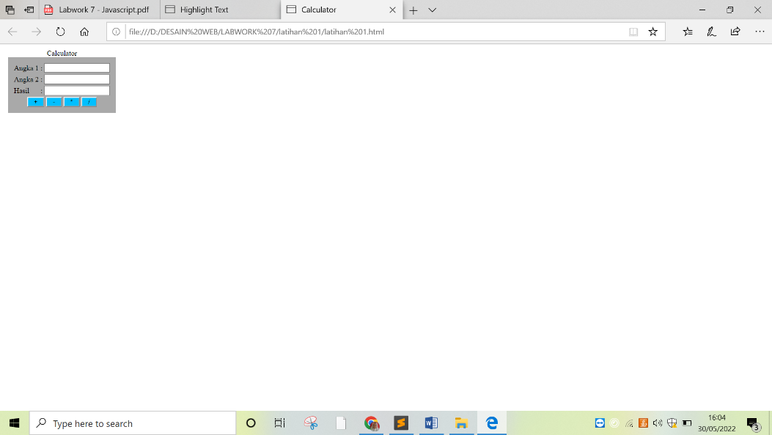

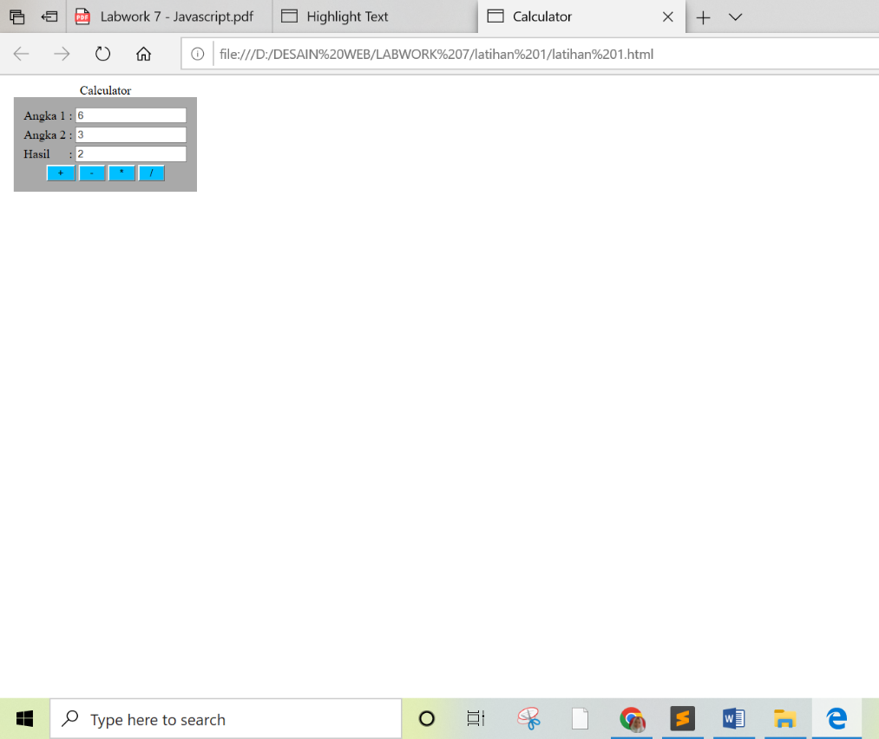

1. Script:

<!DOCTYPE html>

<html lang="en">

<head>

<title>Highlight Text</title>

<style>

.highlight.active {

background-color: yellow;

color: red;

font-weight: 900;

}

</style>

</head>

<body>

<h1>PTIK FKIP UNS</h1>

<p>The <span class="highlight">Faculty of Teacher Training and Education, Sebelas Maret University</span>,

Surakarta is

an Educational Personnel

<span class="highlight">Education Institution (LPTK)</span> which has 24 study programs in 6 majors.

Each study program has its

own

characteristics in producing <span class="highlight">superior, strong and intelligent educational staff.</span>

</p>

<p>

The <span class="highlight"> Informatics and Computer Technology Education (PTIK) </span> study program is planned to take shelter in the

management of the <span class="highlight"> Engineering and Vocational Education (PTK)</span> department. This placement revises our previous

statement, where the PTIK study program is under the P.MIPA department. PTIK is a study program that will

produce graduates who are <span class="highlight"> prioritized to teach in vocational/vocational programs </span>. So, it would be better if PTIK

was under the PTK department which oversees vocational programs such as <span class="highlight"> Building Engineering Education </span>, and

<span class="highlight"> Mechanical Engineering Education</span>. To meet the needs of lecturers in the field of information technology that

cannot be met by the PTK department, PTIK will conduct <span class="highlight"> resource sharing with the mathematics study program</span>.

</p>

<button onclick="Highlight()">Highlight Paragraf</button>

<script>

const highlight = document.querySelectorAll('.highlight');

function Highlight() {

highlight.forEach( (item) => {

if(item.classList.contains('active')) {

item.classList.remove('active')

} else {

item.classList.add('active')

}

})

};

</script>

</body>

</html>

Output:

Tampilan awal:

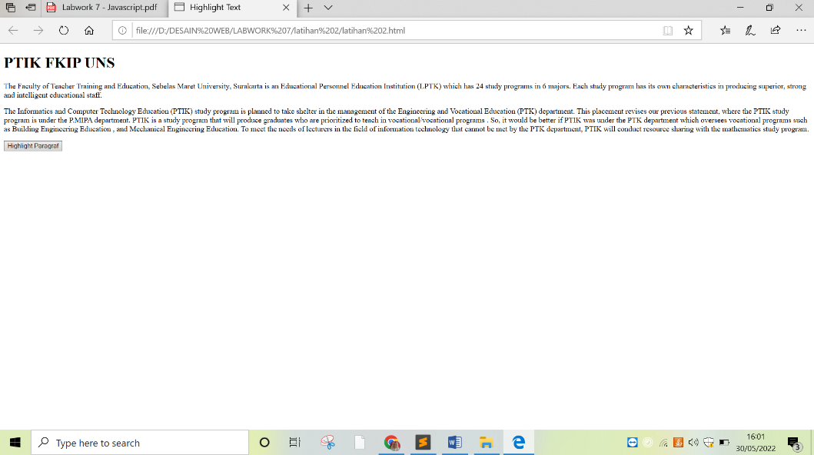

Setelah button di klik:

